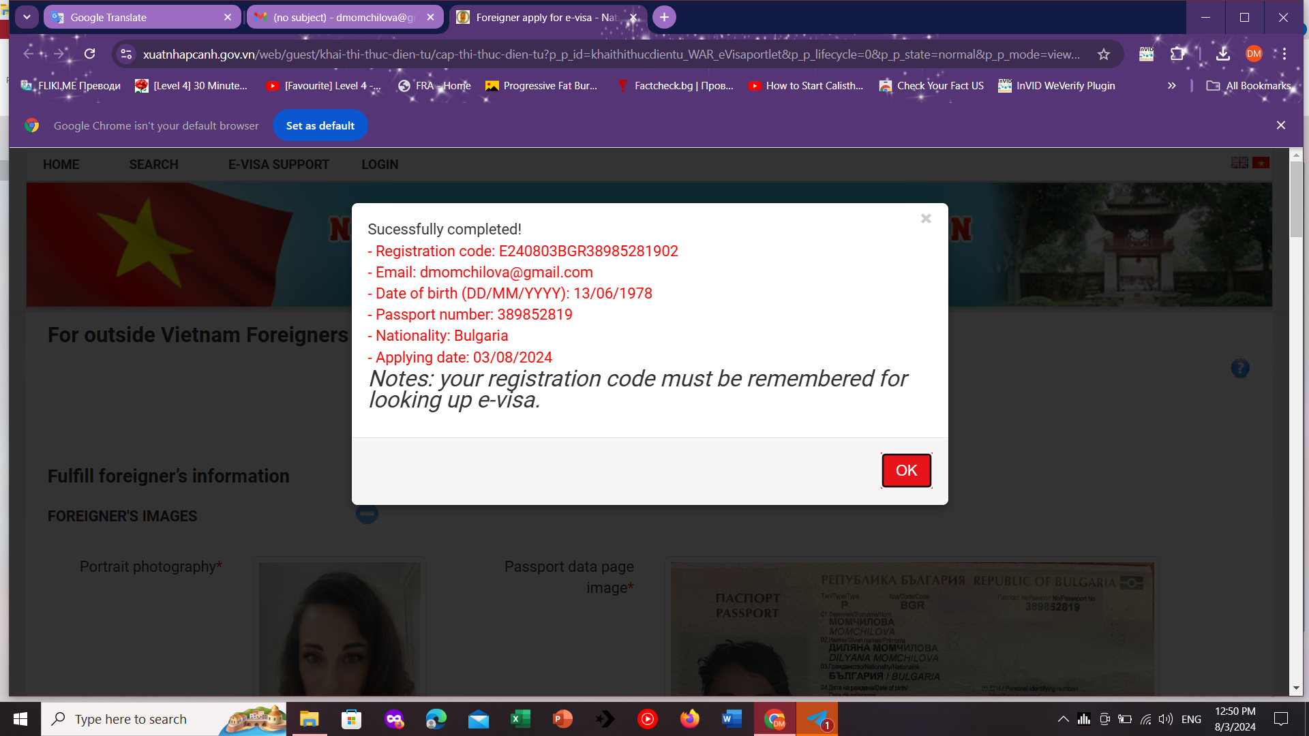
E240803BGR38985281902

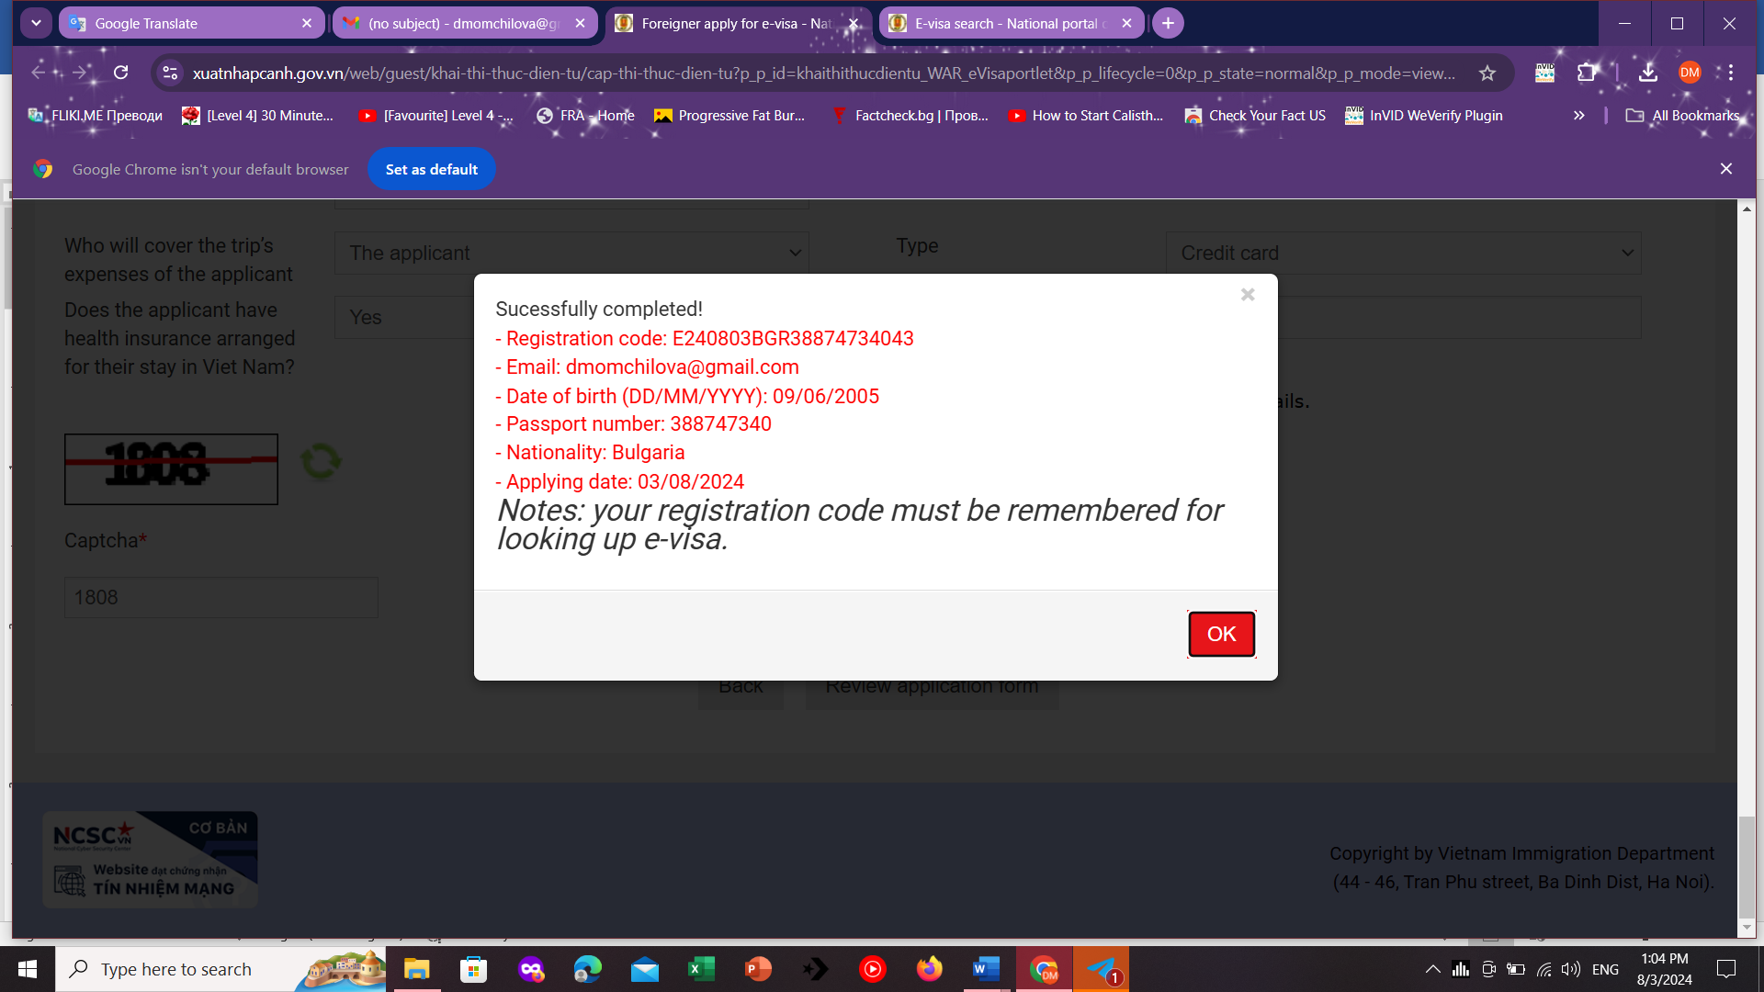
E240803BGR38874734043
Visa is an IMPORTANT PROCEDURE IN THE IMMIGRATION PROCESS, you need to carefully check the application information before submitting and note the following regulations:
Notice: Registration code will be sent via your registered email, therefore, please kindly provide the correct email, and take full responsibility for the provided information.
1. According to regulations, your e-Visa result will NOT BE PROVIDED VIA EMAIL. To check your e-Visa result, follow these steps:
• Step 1: Visit the page: https://evisa.xuatnhapcanh.gov.vn/en_US/tra-cuu-ho-so
• Step 2: Provide the required information, including registration code, email and date of birth to check.
• Step 3: Download, print out your e-Visa and bring it along your entry.
2. According to Article 5 at Resolution 30/2016/QH14 of the Socialist Republic of Vietnam, the e-Visa fee once submitted is NON-REFUNDABLE BY ANY REASONS as the fee is for processing of the application and is NOT DEPENDENT ON EITHER GRANTING OR REJECTION of visa.
3. The e-Visa fee payment status update MAY TAKE UP TO 2 HOURS due to technical reasons/network delays. You need to check your APPLICATION RESULT and PAYMENT RESULT (according to section 1) before RE- APPLYING. If you submit and pay for THE SECOND APPLICATION, which is the same as the previous application, THE IMMIGRATION DEPARTMENT WILL PRESUME THAT THESE ARE TWO DIFFERENT APPLICATIONS and that the previous fee will NOT BE REFUNDED. If both applications are granted a Visa, they are equal use.
4. If your information is not sufficient and valid, you will be requested to provide further information or you can be rejected based on the policy of the Vietnam Immigration Department. When you have to provide the information again, the processing time will be started when you resubmit the VALID information. In this case, take note of the time of entry.
5. The e-Visa is normally processed within 03 working days (*) after the e-Visa fee has been paid with sufficient and valid information.
6. In case of the application to be further verified by The Ministry of Public Security, you will receive the result from 03 to 15 working days (*)
7. For e-Visa support, please check for more information at https://evisa.xuatnhapcanh.gov.vn/en_US/web/guest/faq or directly contact Vietnam Immigration Department at: https://evisa.xuatnhapcanh.gov.vn/en_US//web/guest/lien-he
(*) The working days exclude the weekend and national public holidays.
If you continue to pay, you confirm that you have read and agreed the visa regulations of Vietnam Immigration Department.

